**CSE101 Term Project – Group 15**

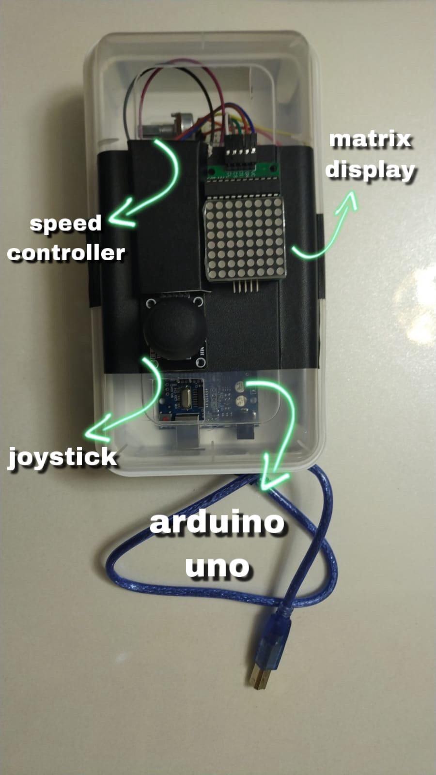**Name of the project**: Console Snake Game V1.5

**Objective**: Remake the epic Snake Game of the Nokia for a portable console.

**Process**: We first began with displaying different shapes on led matrix such as smiley-face and heart. Then we gathered some example codes and executed them to figure out what to do next. While trying tens of different variations of codes, we completed the circuit and started to make the container. After days of hard work now we have a stable, working model.

**Equipments we used:**

Arduino Uno

8x8 Matrix Display

Joystick

Potentiometer 10k(controls snake speed with different voltages)

BreadBoard

Jumper Cables

Power Source (Powerbank)

Sena Nur ULUKAYA

Gökbey Gazi KESKİN

Emre SEZER

Yunus Sefa BAYRAK

Bilal YALÇINKAYA